**Tutorial Daily Class**

**SlimYogi book**

<https://www.womenshealthmag.com/fitness/g26554730/best-warm-up-exercises/>

<https://redefiningstrength.com/35-stretches-stretch-head-toe/>

<https://www.verywellfit.com/how-to-warm-up-for-yoga-3567192>

<http://yogaforhealthyaging.blogspot.com/2017/11/seated-warm-up.html>

<https://yogauonline.com/yoga-practice-tips-and-inspiration/rev-your-yoga-practice-try-seated-warm-sequence>

<https://mymission.lamission.edu/userdata/ruyssc/docs/Stretch-An-Ullustrated-Step-By-Step-Guide-To-Yoga-Postures.pdf>

**31-08-2020-57 Mns**

**step 1- 7mins**

1..start with deep inhale and exhale

2..Pranayam

3..ujjain pranayam

**step-2 warm up exercise- 15 mins**

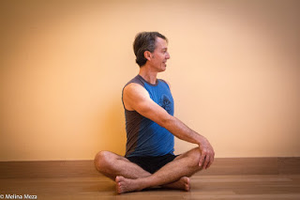**SITTING WARMUP:**

1. **Dynamic to Static Easy Sitting Twist**

* Twist to the right on the exhalation and return to
  + the center on the inhalation. Then twist to the left as
  + you exhale and return to center as you inhale. This is one

round.

* Go back and forth a twice, in rhythm with the breath.
* Then move to the left first on the exhalation and back to the center on the inhalation, and then move to the right and back to the center.
* Then come into static Easy Sitting Twist, relaxing and breathing, for 30-60 seconds, moving first to the right and then to the left.

**2. Easy Sitting Pose, Version 4 (Forward Bend), 30 to 60 seconds, twice**

**1.** Start with your right shin in front of your left and come into the pose as described in [Featured Pose: Easy Sitting Pose](http://yogaforhealthyaging.blogspot.com/2016/06/featured-pose-easy-sitting-pose.html).

2. Stay for 30-60 seconds. Then, come up, move your left shin in front of your right and come into the pose for a second time for 30-60 seconds.

**3. Head turn left to right and right to left**

**4. rotate head with inhale and exhale**

**5. Mountain pose(Strtch ur hands up)**

**6.Butterfly**

**Standing WarmUp**

**1.upper body twist - 10 reps**

❖ stand straight with your legs apart

❖ inhale raise the hands up from the sides on the shoulder level

❖ exhale and turn to the left in the waist keeping both the arms and shoulders straight

❖ turn as far as possible

❖ inhale and twist back to the front

❖ exhale and twist to the right side

❖ this is one round

❖ repeat one more time

**2.Forward and Backward band-10 reps**

❖ stand straight with your legs apart

❖ inhale bring your hands on the waist

❖ exhale and bend forward from the waist keeping the knees straight

❖ bend down as much as possible

❖ inhale and come back to initial position

❖ exhale and bend backward

❖ inhale come back to initial position

❖ this is one round

❖ repeat one more time

**3. Side Band**

❖ stand straight with your legs apart

❖ inhale bring your hands on the waist

❖ exhale and bend the body in the waist to the left side

❖ keep the knees straight

❖ inhale and come back to initial position

❖ exhale and bend the body in the waist to the right side

❖ inhale and come back to initial pose

❖ this is one round

❖ repeat one more time

**4. Upper Body Rotation**

❖ stand straight with your legs apart

❖ inhale bring your hands together above the head

❖ exhale and bend forward from the waist keeping the knees straight

❖ inhale rotate your upper body to the left

❖ continue inhaling and bend to the back

❖ exhale and bend to the right

❖ continue exhaling and bend forward

❖ inhale and go back, rotate to the right

❖ keep inhaling and rotate to the back

❖ exhale and rotate to the left

❖ keep exhaling and rotate to the front

❖ get back to initial standing pose

❖ this is one round

❖ repeat one more time

**5. Hip Rotation**

* + - Start in a standing position,
    - with feet wider than hip-width apart.
    - Bend your arms, and place your hands behind your head. Bend your knee as you lift one leg up.
    - Circle that leg across your body, up toward your chest, then back down to the starting position.
    - Repeat on the other side.
    - **Continue for 30 to 60 seconds.**

**step-3 Poses: 15mins**

1.Sun Salutation-5 sets

**step-4 Sitting Poses: 10mins**

1. 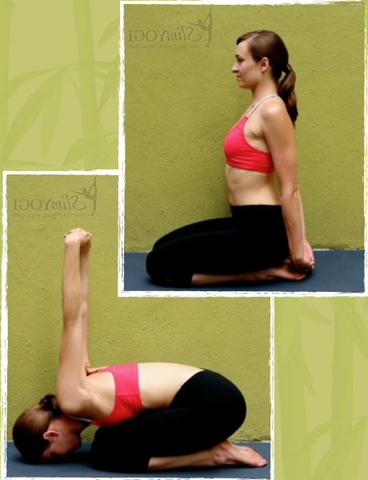**Easy Meditation pose**
2. **Thunder bolr pose 1 & 2**
3. **Vajrasana**
4. **Virasana**
5. **Mandukasana**

**step-5 Savasana 10mins**